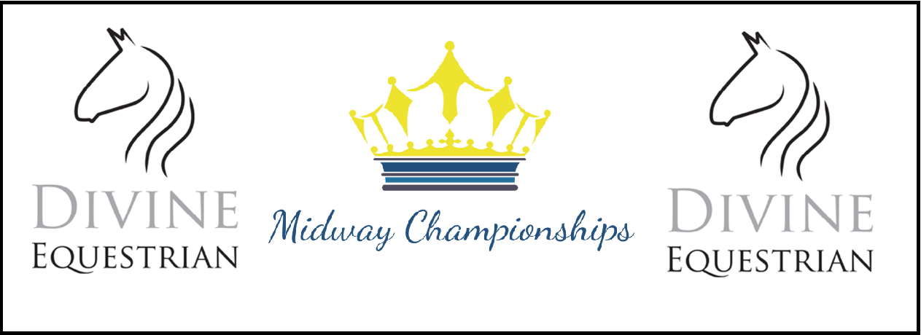

The Midway Championships
Rider Bursary

The Midway Championships is now approaching its 5th Anniversary Year and we are delighted to announce our Rider Bursary Scheme

We will be awarding the following Bursaries for 2020.

£1000 For the person who demonstrates a commitment to competition success, development and progression.
Is able to explain how this funding will help their development in 2020
Set out clear objectives and Goals that are achievable in 2020
Have supported The Midway in the past by going over and beyond the expectations of the organizing committee

£500 Two people who demonstrate a commitment and competition success
Who is able to explain how this funding will help their development in 2020
Show a clear plan to moving up the levels with their horse(s)

£200 Two people who demonstrate a commitment to competition success
Has a clear goal but needs support to enable them to achieve their dreams in 2020
Is new to dressage and keen to learn and develop

This bursary is open to all riders who meet the criteria set out below.

Criteria

- All applicants must be aged 14 or over at 31st December 2019
- Applicants may not be on ANY World Class Funded Programme
- Applicants must have either competed at The Midway Championships in at least 2 different years since its inception in 2016. 2017, 2018 or 2019 or if they have been unable to compete must have volunteered in two different years.
- May only apply once for this funding
- Is a current competing BD Member at Dressage, MyQuest or Team Quest
- Must be eligible for The Midway Championships under the current eligibility criteria as at the date of the award

To apply you will need to:

- Complete the attached application form which will then be assessed by The Midway Championships Bursary Committee and awarded by them.
- The Committee are under no obligation to award all bursaries available
- Their decision is final and may not be disputed or challenged
- Confirm your BD Competition Record for 2019
- Submit your form by the closing date which is 31 January 2020

Rider Name
BD Reg. No
Date of Birth
Email
Phone Number
Years you have competed or volunteered
Which years you have competed or volunteered at Midway Championships
Please tell us why you feel you deserve this award

Please tell us how you would plan to use this funding

Please explain why you compete and what your dream for the future is

Please provide below details of your BD, TQ, MQ results in the past 6
Months

